

***Southend, Essex and Thurrock Domestic Abuse Board***

**Domestic Abuse and Working with Older People**

Issued: December 2017

**C O N T E N T S**

|  |  |
| --- | --- |
| ***Section*** | ***Page Number*** |
| Background | 1 |
| Introduction | 2 |
| What is Domestic Abuse? | 3 |
| Domestic Abuse and Older People the Extent of the Issue | 6 |
| Domestic Abuse Policy and Legislative Context | 9 |
| Future Opportunities | 12 |
| Signposting | 15 |

**B A C K G R O U N D**

& P U R P O S E O F T H E

D O C U M E N T

This document is for professionals engaged in working directly or indirectly with older people who may have care and support needs, whose circumstances make them vulnerable, and who may also be victims of domestic abuse.

The purpose of this document is to aid understanding of domestic abuse and its impact on older people and to help you to provide informed and more effective support to older people who experience domestic abuse.

In order to make the connections between adult safeguarding and domestic abuse always follow your local policies, protocols and procedures for safeguarding adults and children, and for domestic abuse.

[Southend, Essex and Thurrock Safeguarding and Child Protection Procedures](http://www.escb.co.uk/Portals/67/SET%20Procedures-April%202017-updated.pdf)

[Southend, Essex and Thurrock Adults Safeguarding Guidelines](http://www.essexsab.org.uk/Portals/68/Professionals/SET%20Safeguarding%20Guidelines%20%20-%20V4.2%20March17.pdf)

The document will be useful to those who have time limited interactions with survivors, perpetrators or their children, as well as those who provide longer-term interventions. The document should be used as a reference source to aid you when you are working with an individual or family.

1

**I N T R O D U C T I O N**

D O M E S T I C A B U S E

& O L D E R P E O P L E

The complex issue of domestic abuse is often compounded by the dynamics of ageing which discourages disclosure. Domestic abuse is wide reaching; a largely hidden issue and often goes unrecognised by professionals due to a lack of awareness and professional curiosity, making identification even more challenging.

Each year, around 2.1 million people are victims of domestic abuse in England and Wales – 1.4 million women (8.5% of the population) and 700,000 men (4.5% of the population). Crucially, 85% of victims made five attempts on average to get support from professionals in the year before they accessed effective help to stop the abuse (Safe Later Lives, 2017).

The impact of domestic abuse is serious on all victims; however, certain groups experience additional challenges and barriers to disclosing abuse and seeking support, advice and/ or guidance. The limited pool of research which does exist on domestic abuse and older people suggests that “older women’s experiences of domestic abuse are markedly different from those in younger age groups and that these differences have not been adequately acknowledged or accounted for” (Safe Later Lives, 2017).

2



**W H A T I S**

D O M E S T I C A B U S E ?

Domestic abuse is about one person exerting power and control over another. Domestic abuse is unacceptable and affects people from all social and economic backgrounds, regardless of age, ethnicity, religion or sexual orientation. It includes any action involving abuse between adult family members (including current and former partners).

The abuse occurs when a person causes, attempts to cause, or threatens to cause emotional, financial, sexual or physical harm to an intimate partner or other family member. Domestic abuse is not exclusive to younger people or women with children; anybody can be a victim of domestic abuse. For older people abuse may have been a significant feature of most of their adult lives, an ongoing issue for them, or domestic abuse can start when they reach an older age and/ or become frail or cognitively impaired. There are examples of survivors who have lived with abuse for 40+ years in Southend, Essex and Thurrock.

A pattern of coercive behaviour can be used by an individual to establish and maintain power and control over another. This type of behaviour takes many forms, including physical, sexual, economic and emotional abuse, isolation and the selective destruction of property and pets. It is also rarely a one-off event. It can escalate in frequency and severity over time. The majority of victims are women but domestic abuse happens to men as well.

3

**The information below will provide an insight into abusive behaviour, and how these behaviours are defined**.







4



**There is no specific offence of ‘domestic abuse’ under criminal law, but many forms of domestic abuse are crimes.**





5



**D O M E S T I C A B U S E**

& O L D E R P E O P L E -

T H E E X T E N T O F T H E I S S U E

It is estimated that in the last year approximately 120,000 individuals aged 65+ have experienced at least one form of abuse on a national scale (psychological, physical, sexual or financial); with only 3% of the older persons community receiving support from Independent Domestic Violence Advocates (IDVA) (Safe Later Lives, 2017).

**Local Findings show that:**

* *Over a 12-month period, Southend, Essex and Thurrock data highlights that the 65 and over age group recorded both the highest percentage (25.5%) and volume (additional 183 offences) increase of domestic abuse incidents (2015 compared to 2016).*
* *At the point of the last Domestic Homicide Thematic Annual Review 4/11 homicides were over the age of 65 years.*

6

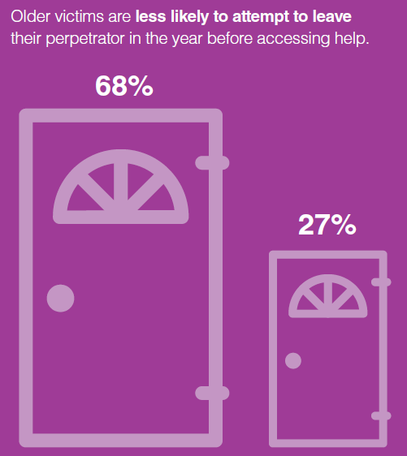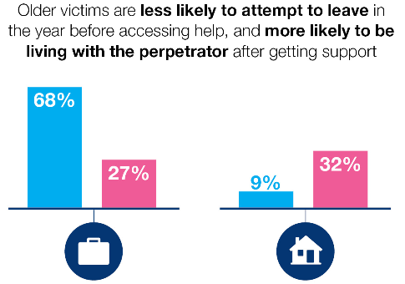 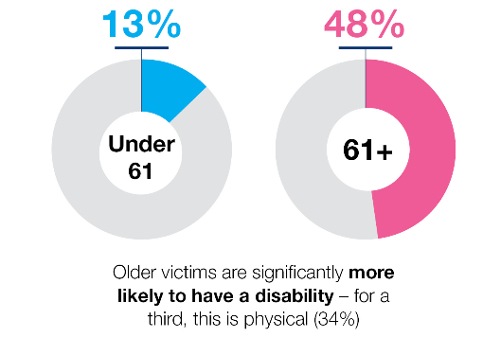

**The Safe Lives Older Person’s Spot light (2017) highlighted:**

**Stay**

**Leave**

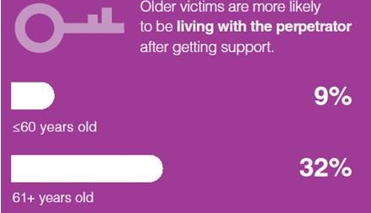

**61+ years**

**Under 60 years**

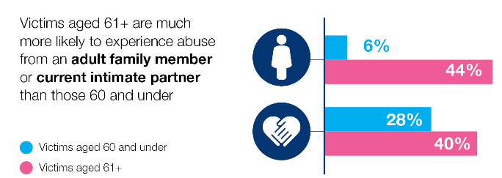

**Adult family member**

**Current intimate partner**

7

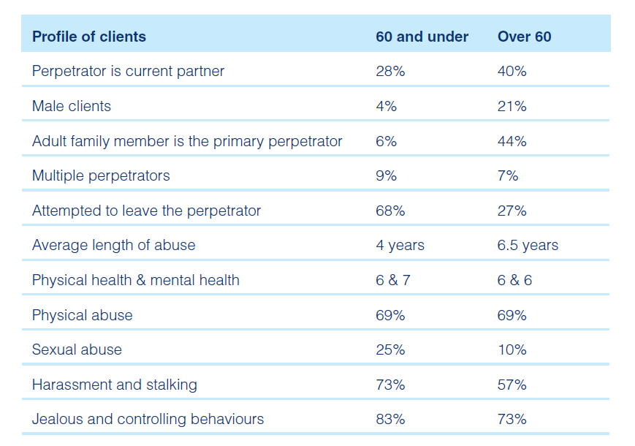

**Data from: Safe Lives Older Person’s Spot light (2017)**

**The table highlights some differences between the under and over 60’s age group**.

8



**D O M E S T I C A B U S E**

P O L I C Y & L E G I S A T I V E C O N T E X T

Older victims of domestic abuse do not typically benefit from generic policy provision, as they require more

tailored responses to fit their needs. This is supported by the Government’s ‘Ending Violence against Women

and Girls’ (VAWG) strategy (2016–2020), there is no generic approach to providing services to victims of violence and abuse as needs can be complex. The Home Office update to the VAWG strategy in April 2017 described older people as forming a group that “experience multiple disadvantage”.

Guidance has been issued by the Local Government Association (LGA) and association of directors of adult social services (Adass) which sets out key UK legislation which provides the basis for safeguarding older people experiencing domestic abuse. The Statutory Guidance issued under the Care Act (2014), states that adult safeguarding means ‘protecting an adult’s right to live in safety, free from abuse and neglect’ (Section 14.7). Safeguarding duties apply to an adult who:

‘*has needs for care and support (whether or the not the authority is meeting any of those needs) is experiencing, or is at risk of, abuse or neglect as a result of those care and support needs is unable to protect themselves from either the risk of, or the experience of abuse or neglect’*. (Section 14.2).

9

**Section 14.11 is particularly relevant to older people affected by domestic abuse:**

The Care Act (2014) specifies that freedom from abuse is a key aspect of a person’s wellbeing. The guidance outlines that abuse takes many forms and professionals not be constrained in their view of what constitutes abuse. It describes the following types of abuse, which include exploitation as a common theme:

* ***Physical abuse***
* ***Domestic violence***
* ***Sexual abuse***
* ***Psychological abuse***
* ***Financial or material abuse***
* ***Modern slavery***
* ***Discriminatory abuse***
* ***Organisational abuse***
* ***Neglect and acts of omission***
* ***Self-neglect***

The Care Act also states that abuse can be caused deliberately or unintentionally. Domestic violence is a category of abuse which was added to the existing list of categories following consultation on the draft Care Act guidance. Financial abuse has also been highlighted further in the Care Act guidance following consultation as the signs can present differently from other more physical signs of abuse. Below outlines that the aims of adult safeguarding are to:

10

* ‘Stop abuse or neglect wherever possible
* Prevent harm and reduce the risk of abuse or neglect to adults with care and support needs
* Safeguard adults in a way that supports them in making choices and having control about how they want to live
* Promote an approach that concentrates on improving life for the adults concerned
* Raise public awareness so that communities as a whole, alongside professionals, play their part in preventing, identifying and responding to abuse and neglect
* Provide information and support in accessible ways to help people understand the different types of abuse, how to stay safe and what to do to raise a concern about the safety or well-being of an adult
* Address what has caused the abuse or neglect.’

M A K I N G T H E L I N K – D O M E S T I C A B U S E &

S A F E G U A R D I N G

A significant proportion of people who need safeguarding support do so because they are experiencing domestic abuse. Despite the clear overlap between work to support people experiencing domestic abuse and safeguarding adults work, the two have developed as separate professional fields. Clear strategic and practice links need to be made between the approaches.

11



**F U T U R E O P P O R T U N I T I E S**

Many challenges older people face are not too dissimilar to others experiencing domestic abuse.

However, older victims’ experiences are often intensified by social, cultural and physical factors that require a

tailored response. The Safe Lives Spotlight study (July and August 2016) highlighted that clients over 60 are less likely to have attempted to leave their abuser than those under 60 years (17% vs 29%). Key findings are detailed below which you should consider when working with older victims of domestic abuse.

**H I D D E N C O M M U N I T Y**

* National research consistently shows that older people are underrepresented in domestic abuse services.
* Research suggests that as a consequence of small numbers of older victims accessing domestic abuse services, professionals tend to believe that domestic abuse does not occur amongst older people.
* Assumptions encourage professionals to link injuries, confusion or depression to age related concerns rather than domestic abuse. Local and National Domestic Homicide Reviews support this finding.

**To be considered within your practice: Have regular contact with older people to build relationships enabling them to talk about their experiences with you and encourage them to access support.**

12

**L O N G T E R M A B U S E & D E P E N D E N C Y I S S U E S**

* There are additional pressures to remain within the relationship such as, contributions to the family home or other assets. Older victims may have increased fear over the change in long-term family dynamics that could occur and pressures presented by adult-children.
* Older people are statistically more likely to suffer from health problems, reduced mobility or other disabilities, which can exacerbate vulnerability.
* Opportunity for services to speak to victims alone is significantly reduced as older victims are more likely to be living with their perpetrator.

**To be considered within your practice: Earlier identification, professional curiosity and using your window of opportunity will support older victims to disclose in a safe environment which will enable you to signpost or offer advice and support.**

**G E N E R A T I O N A L S I L E N C E**

* Older people are less likely to identify abuse; this can act as a barrier to them approaching services.
* Older people have reported that the family life is private; they do not discuss matters that occur behind closed doors.
* Older people are less aware of the domestic abuse specialist services available to them.

**To be considered within your practice: Earlier identification, professional curiosity and using your window of opportunity will support older victims to disclose in a safe environment.**

**Never assume that older people are aware of the services available to them.**

**Be aware that older people are less likely to disclose, ensure you ask appropriate questions and give victims the opportunity to talk.**

**Embed domestic abuse champions within the adult services sector.**

13

**I N C R E A S E D R I S K O F A D U L T F A M I L Y A B U S E**

* 44% of respondents aged 60+ were experiencing abuse from an adult family member, compared to 6% of younger victims.
* Older victims may fear disclosure to authorities of this type of abuse. They might want to maintain their relationship for a variety of reasons such as, the adult child may provide their care needs.
* Services require more awareness of different dynamics of domestic abuse.

**To be considered within your practice: Ensure that domestic abuse is fully considered at adult safeguarding enquiries - ensure practitioners recognise the dynamics of abuse between intimate partners or from family members and make the appropriate.**

**N E E D F O R G R E A T E R C O O R D I N A T I O N B E T W E E N S E R V I C E S**

* Professionals aren’t identifying that there are domestic abuse issues for older people; they are being treated as safeguarding issues and therefore tend to get caught up in a wide remit without a tailored response.
* From DHR Case Analysis, Standing Together found that “a significant proportion of adults who need safeguarding support do so because they will also be experiencing domestic abuse. Yet despite the overlap, the two have developed as separate fields”.

**To be considered within your practice : Build closer working relationships between adult safeguarding and Independent Domestic Violence Advisors (IDVAs) and other professionals working with older people.**

**Implementation of joint visits to older victims with professionals who the older person already trusts.**



**S I G N P O S T I N G**

**In an emergency dial 999**

**Non-emergency Police enquiries 101**

L O C A L S P E C IA L I S T

DA S E R V I C E S

**Safer Places**

<http://www.saferplaces.co.uk/>   
Tel: 03301 025811

**Colchester & Tendring Refuge**

<http://www.colchester-refuge.org.uk/>

Tel: 01206 500585

**Changing Pathways**

<http://changingpathways.org/>

Tel: [01268 729707](tel:01268729707)

**SOSDAP**

<http://www.sosdap.org/?_sm_au_=iDVHZfPPVrQ3574s>

Tel: 01702 302333

**The Change Project**

<http://www.thechange-project.org/>  
 Tel: 01245 258680

**Victim Support**

<https://www.victimsupport.org.uk/>

Tel: 0300 3030165

**Older Persons care pathways as recommended by Safe Lives:**

**The document is a generic pathway that you can tailor to your local area.**



If you have a safeguarding concern which is not an emergency please contact your local adult social care teams:

**Essex**: 0345 6037630

**Southend**: 01702 215008

**Thurrock**: 01375 652868

15

M U L T I – A G E N C Y R I S K A S S E S S M E N T

C O N F R E N C E (MARAC)

Multi-Agency Risk Assessment Conference (MARAC) is a victim focused process in which the needs of high risk victims of domestic abuse cases and the risks posed by the perpetrator are considered in a multi-agency forum and a joint safety plan is constructed around the individual.

All agencies have a valuable role to play in safety planning for victims and we will ensure you receive information and are able to make a contribution.

Please contact the relevant email address below for the MARAC referrals form, you will also need to complete a DASH risk assessment with this and submit to your local Multi-agency risk assessment team (MARAT).

DASH (**D**omestic **A**buse, **S**talking, harassment and **H**onour based violence) 2009 risk assessment model provides a national, accredited risk assessment process which can be used by any agency. The purpose is to give a consistent and practical tool to practitioners working with victims of domestic abuse to help them identify those who are at high risk of harm and whose cases should be referred to a MARAC meeting - in order to manage the risk. Additional information is available at [www.dashriskchecklist.co.uk](http://www.dashriskchecklist.co.uk/index.php?page=dash-2009-model-for-practitioners) and [DASH](http://www.safelives.org.uk/sites/default/files/resources/Dash%20without%20guidance%20FINAL.pdf)

**Southend**: [southenddfpsafeguarding@southend.gcsx.gov.uk](mailto:southenddfpsafeguarding@southend.gcsx.gov.uk)

**Essex**: [MARACESSEX@essex.pnn.police.uk](mailto:MARACESSEX@essex.pnn.police.uk)

**Thurrock**: [thurrockmash@thurrock.gcsx.gov.uk](mailto:thurrockmash@thurrock.gcsx.gov.uk)

16