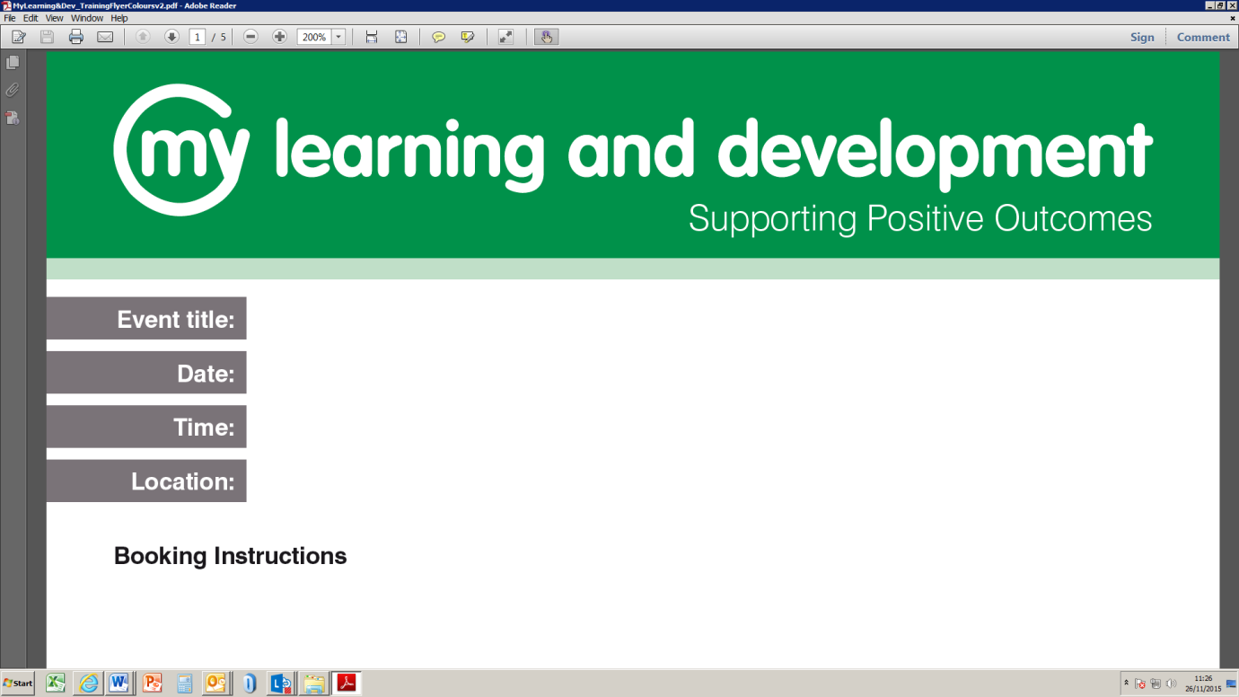

**Description**: This course is intended for carers/coordinators however anyone is welcome to attend to get an understanding of the Mental Capacity Act. DoLS are not covered in this training.

**Intended Audience**: Anyone working on a day-to-day basis with adults in a housing, health or social care setting.

**Learning objectives:**

* What is mental capacity
* What is the act and what did it introduce
* The five principles of the act
* Helping people to make decisions
* Assessing capacity
* Best interests

|  |  |  |
| --- | --- | --- |
| **Date** | **Time** | **Venue** |
| 26/11/18 | 13:30 to 16:30 | Civic Offices GFTR - RM17 6SL |
| 20/12/18 | 10:30 to 14:30 | Civic Offices GFTR - RM17 6SL |
| 17/01/19 | 10:30 to 14:30 | Civic Offices GFTR - RM17 6SL |
| 06/03/19 | 13:30 to 16:30 | Civic Offices GFTR - RM17 6SL |
| 09/04/19 | 10:30 to 14:30 | Civic Offices GFTR - RM17 6SL |
| 29/05/19 | 10:30 to 14:30 | Civic Offices GFTR - RM17 6SL |
| 02/07/19 | 10:30 to 14:30 | Civic Offices GFTR - RM17 6SL |
| 12/11/19 | 10:30 to 14:30 | Civic Offices GFTR - RM17 6SL |

Book via Oracle Employee Self-Serve or Managers Self-Serve

Further queries email Mylearning@thurrock.gov.uk

Mental Capacity Act for Front-line Workers (MCA)

See table below

See table below

Civic Offices, Ground Floor Training Room – RM17 6SL