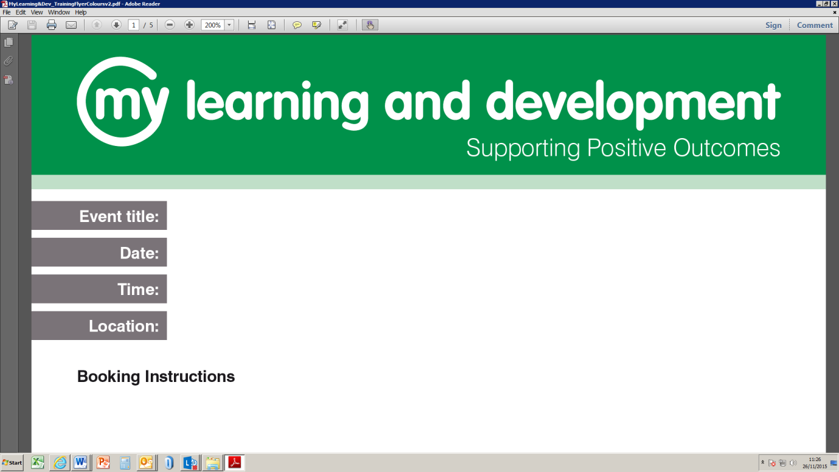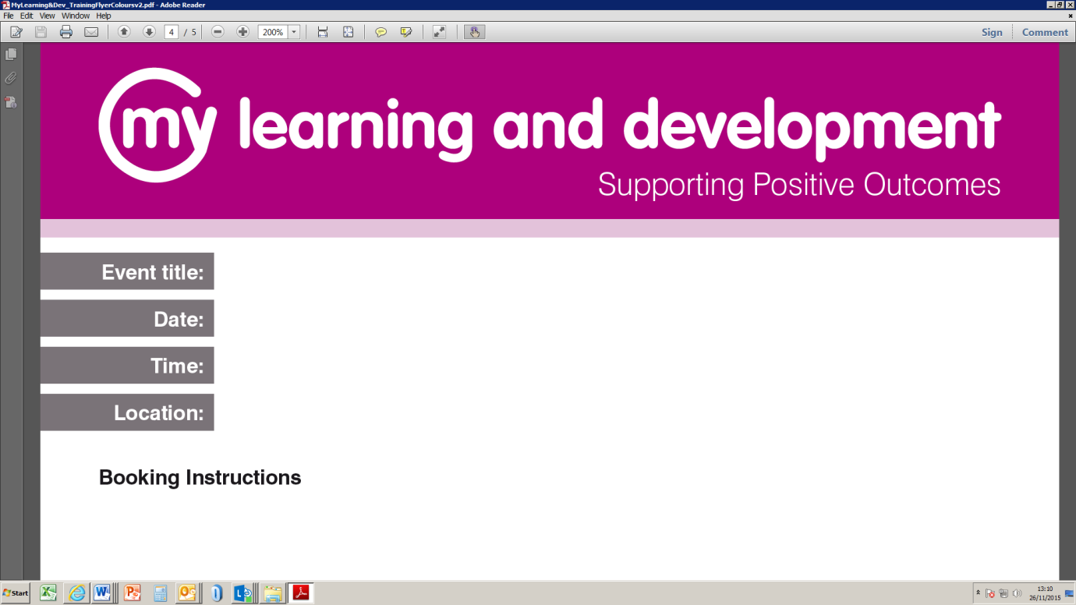

Personality Disorder Training: Expected Outcomes:

The training is dedicated to the wellbeing of all and offers a stepwise approach to developing a more comprehensive working model of personality disorder in general; whilst providing a detailed focus on the Borderline Personality Disorder / Emotionally Unstable Personality Disorder diagnoses. At the end of this training, delegates will have:

* An understanding of the relationship between childhood trauma and attachment problems and how these manifest in the various personality disorder diagnoses and symptomology;
* Understanding the cognitive and behavioural vulnerabilities associated with Personality Disorder and the common problems that challenge service providers;
* An improved understanding of non-suicidal self-injury (NSSI) and para suicidality. Their functions and associations with Personality Disorder and psychiatry in general. With a view to informing best practice in interaction styles and risk management;
* Understand how certain behaviours associated with personality disorder can impact upon staffs ability to support and maintain empathy /compassion;
* Understand the importance of ‘empathic boundaries’;
* Improving communication and interactional skills through appropriate validation and dialectic-orientated communication styles;
* Understand and recognise the common psychiatric disorders that may co-present with Personality Disorder;
* A clearer understanding of the experience of Personality Disorder from the perspective or service users;
* Understand Personality Disorder from the perspective of the NHS;
* Understanding Personality Disorder from the viewpoint of forensic psychiatry to improve safety on certain occasions;
* Understanding the psychotherapies dedicated to the field of Personality Disorder and how to employ their principles to improve support;
* Develop and implement crisis plans to support individuals at potential risk;
* Recognising risks and emergencies and escalating concerns / communicating appropriately with key healthcare providers and emergency services;
* Access to a wide range of peer-reviewed articles associated with suicide science;
* All delegates receive A 50-page industry-standard diagnostic workbook (DSM5) and access to further learning materials and peer-reviewed articles;

Access to free post-training support.

Thurrock staff: please book via Oracle Employee Self-Serve or Managers Self-Serve. Further queries email Mylearning@thurrock.gov.uk

Understanding Personality Disorder (PD) – 6 x 1-day sessions

10/05/19, 12/06/19, 11/07/19, 04/09/19, 09/10/19, 14/11/19

09:30 to 16:30

Civic Offices, Ground Floor Training Room – RM17 6SL