Easy
Read
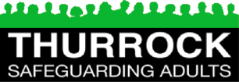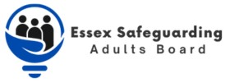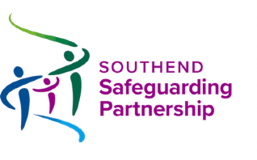

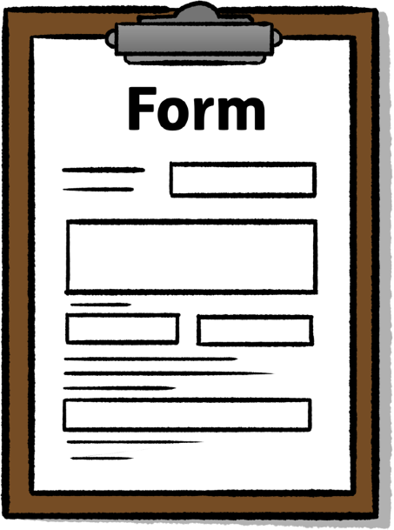
Be safe from abuse form

Safe

The Understanding and Reporting Abuse Easy Read guide will tell you what abuse is and the types of abuse.

Contents

Introduction 3
About you 4
What do you want to tell us? 5
What you should do now 8
What happens next 10

In this Easy Read document, hard words are in bold. We explain what these words mean in the sentence after we have used them.
Bold
words

Some words are blue and underlined.

links
These are links that will go to another website which has more information.

Introduction
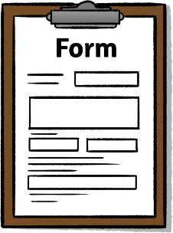
This form is from Safeguarding Adults Boards in Essex, Thurrock and Southend.

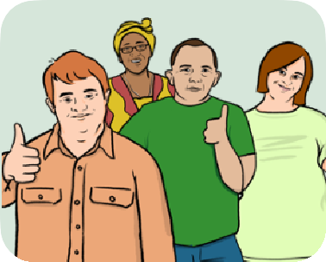
Safeguarding Adults Boards work to:

Safe
- Keep adults safe from harm.

- Support adults who have been treated badly or not looked after
properly.

This form is for you to fill in if:
- You are worried that someone is harming you or someone else.

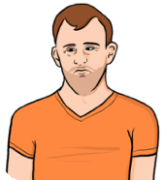
- You would like some help with this and want it to stop.
I need
help

About you
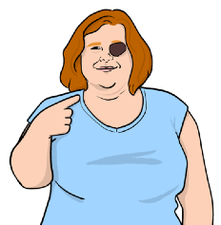
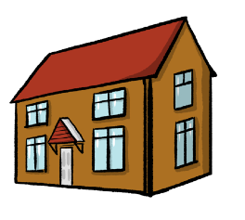
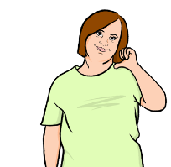
Question 1: What is your name?

Question 2: What is your address?

Question 3: What is your phone number?
Question 4: What is your email address?

What do you want to tell us?
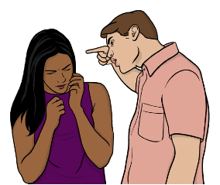
Question 5: Are you being harmed?
Yes
No
Question 6: Is someone else being harmed?
Yes
No
If you said yes, what is their name?

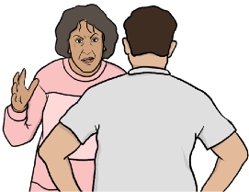
Question 8: Would it be OK for someone to come and see you to help?
Yes
No
If you said no, can you tell us why?
Question 7: Do you want it to stop?
Yes
No

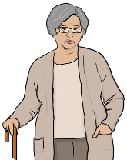

Question 9: What do you want to happen?

What you should do now

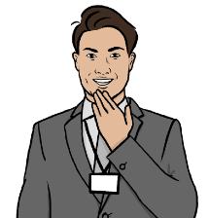
What you should do now

Thank you for filling in this form.

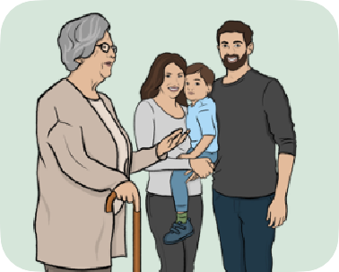
Please give this to someone you trust. This could be:
- A family member.

- A doctor or nurse.

- A care worker.

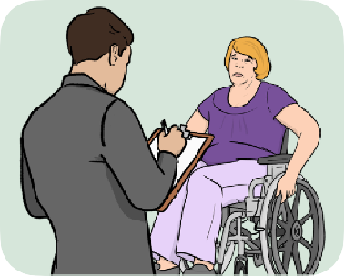
- A social worker.

If you don’t have anyone to give this form to, you can contact your local council using these details.

Southend
- Email: accessteam@southend.gov.uk
- Phone: 01702 215 008

Essex
- Email: businesssupport.adultsovas
@essex.gov.uk
- Phone: 0345 603 7630

Thurrock
- Email: thurrock.first@thurrock.gov.uk
- Phone: 01375 511 000

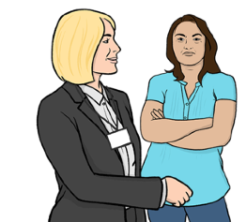
What happens next
When we have got your information from this form, we will speak to you and ask you what you want to happen.

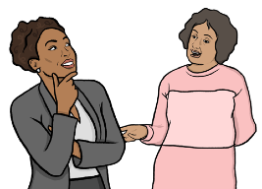
If you do not have anyone to support you, we will talk about finding an advocate.
An advocate is someone who helps you to speak up, or speaks up for you.

We might have to talk to other organisations about how we can best help you.

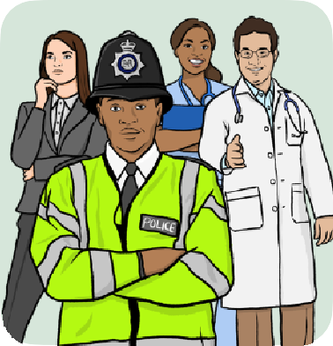
Some of the people we might talk to are:
- The police.
- Nurses or doctors.
- Anyone that has been working with you or helping you already.

This Easy Read information has been produced by easy-read-online.co.uk

